Artificial Intelligence (LAB)
Lab Task no.3

Submitted by:
Rana M. Moiz Safdar
Roll Number:
SU92-BSAIM-F25-209
Class/Section:
BSAI-3D
Submitted to:
Sir Rasikh ALi

Question 1. BFS and DFS
TREE / Graph :
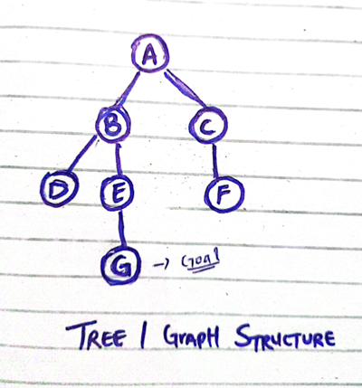
BFS :
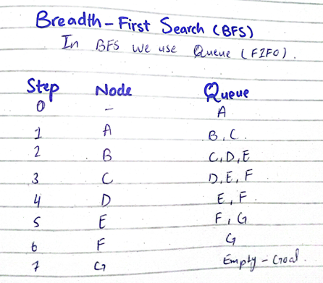
BFS final path: A → B → E → G
DFS :
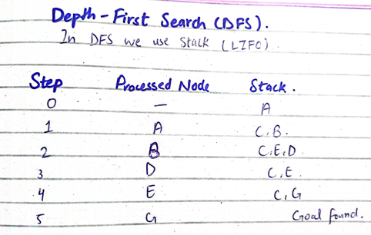
BFS final path: A → B → E → G
Comparison in BFS and DFS
 | BFS | DFS
Data structure | Queue (FIFO) | Stack (LIFO)
Visited Nodes | A,B,C,D,E,F,G | A,B,D,E,G
Final Path | A-B-E-G | A-B-E-G
Question 2. DLS and IDDFS:
FOUND: means the goal is reached.
CUTOFF: means a deeper unexplored path exists beyond the limit. We just have stopped before reaching it.
FAILURE: means the explored search space is exhausted without a goal or a depth cutoff. Mean we didn’t get it any answer.
Result of DLS:
Depth Limit | Result | Explanation
1 | CutOff | Goal is deeper than limit
2 | CutOff | Goal is at depth 3
3 | Found | Goal is found at Depth 3
4 | Found | Goal is found before maximum limit
The Goal is at depth 3 so that why 1 and 2 will show cut off because it didn’t reach the required depth.
Result of IDDFS:
Depth Limit | Status
0 | CutOff
1 | CutOff
2 | CutOff
3 | Found
4 | Found
The Goal is at depth 3 so that why 1 and 2 will show cut off because it didn’t reach the required depth.
Complete Info:
There is “Cutoff” when the goal is deeper than Limit, “Found” when Goal is found within limit and the Last is “Failure” when its unable to find. DLS controls how deeply DFS can search by using a depth limit. IDDFS repeatedly increases this limit until it finds the goal. In this graph, both algorithms find the path A → B → E → G when the allowed depth reaches 3. The path local cycle check prevents revisiting a node already on the current path, while allowing the same node to be explored in a different iteration.

Question 3. BFS vs Uniform Cost Search (UCS)
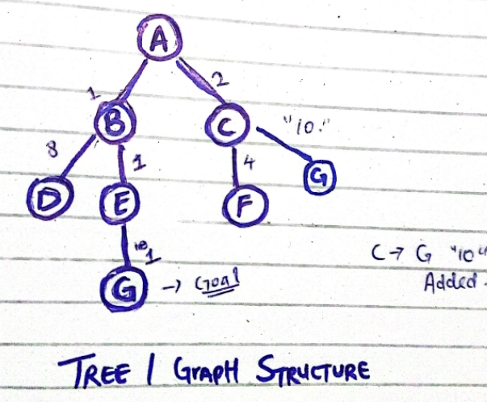
Edges and Costs:
The edges and cost of path, I used in the python code are following:
Edge | Cost
A → B | 1
A → C | 2
B → D | 8
B → E | 1
C → F | 4
C → G | 10
E → G | 1
Results:
Result | BFS | UCS
Path | A → C → G | A → B → E → G
Number of edges | 2 | 3
Total Cost | 12 | 3
UCS found the minimum cost Path with the total cost 1+1+1=3 and its order of visiting was ABCEG. Nodes with lower cost values.
Whereas BFS focused on less edges and even tho it used less edges than UCS 2>3 it still had higher cost path because 2+10=12(for reaching the same Goal G). Therefore a path with fewer edges can be more expensive than path with more edges.

